Sepsis Cases – Case 3
Summary of Case Scenario:

An 18 year old male is brought to ED with altered level of consciousness as a result of severe DKA and pneumonia. He will require vigorous fluid resuscitation, and recognition of ketoacidosis as the major contributor to his acidosis, with initiation of insulin therapy in addition to treatment of his sepsis.

Equipment Setup & Moulage:

- Mannequin: Male patient in street clothes, one peripheral IV
- Standard Resuscitation Equipment, central line kit and a LTV ventilator available.
- Central line neck set up on small table, covered but available as required.

Participant Roles:

- Physician team leader
- 2nd physician
- Nurses x 2 (will need earpieces)
- Respiratory therapist
- Roommate

Mannequin Programming:

Parameter | Initial Setting
HR | 130, sinus
BP | 75/40
RR | 30, Kussmaul resps
Saturation | 92% room air
Temp | 38.4
Eye Opening | Closed

Case Progression:

Patient is an 18 year old and a new first-year university student in the first week of orientation. His roommate accompanies him and knows very little about him, other than that he seems like a bit of a “dud” who “keeps to himself.” The roommate has noticed that the patient’s been coughing quite a bit at night since moving into residence. He also wonders if the patient is a drug user, as he thinks he saw the patient hiding a syringe one day when he came into the room. In the past 48 hours, the patient has seemed more “out of it” and tonight the roommate came back to the room to find him unresponsive on the floor of their room.

The patient moans to painful stimuli, but is otherwise unrousable. He is tachycardic and hypotensive, with marked tachypnea. Initial finger-stick blood glucose reads “high”. He will require vigorous fluid resuscitation with slight improvement to his blood pressure, but no change in his LOC. He will require intubation, and initiation of insulin therapy. If not adequately ventilated peri-intubation, he will have a PEA arrest with agonal rhythm. Otherwise, he will remain hemodynamically unstable requiring vasopressor support. If insulin therapy is not initiated, he will proceed to PEA arrest after about 15 minutes.

Case Stem (Provided to Participants)

EMS has just transported this 18 year old male first-year student from his residence at Queen’s University, accompanied by his roommate. It’s the first week of orientation. He was found by his roommate unresponsive on the floor this evening.

Laboratory Results

VBG
pH 6.83 (7.37-7.44)
pCO2 9 (31-42)
pO2 35 (80-95)
HCO3 2 (21-29)
O2 sat 0.99 (0.96-0.99)
Base Excess -35.9

CBC
WBC 30.1 (4-10)
Hb 163 (120-160)
Plt 471 (150-400)

Chemistry
Na 134 (133-145)
K 3.7 (3.5-5.2)
Cl 108 (95-107)
CO2 5 (21-29)
Creat 124 (0-80)
BUN 7.0 (3.0-7.0)
Glucose 47.3 (3.5-11.1)
Albumin 24 (35-55)
Amylase 180 (36-128)
Bilirubin 28 (0-17)
ALT 90 (25-100)
AST 80 (40-90)
Calcium 1.66 (2.15-2.65)
Magnesium 0.74 (0.8-1.0)
Phosphorous 0.39 (0.80-1.50)
CK 30 (35-155)
Osmolality 394 (281-297)
Lactate 3.9 (<2.5)
CXR

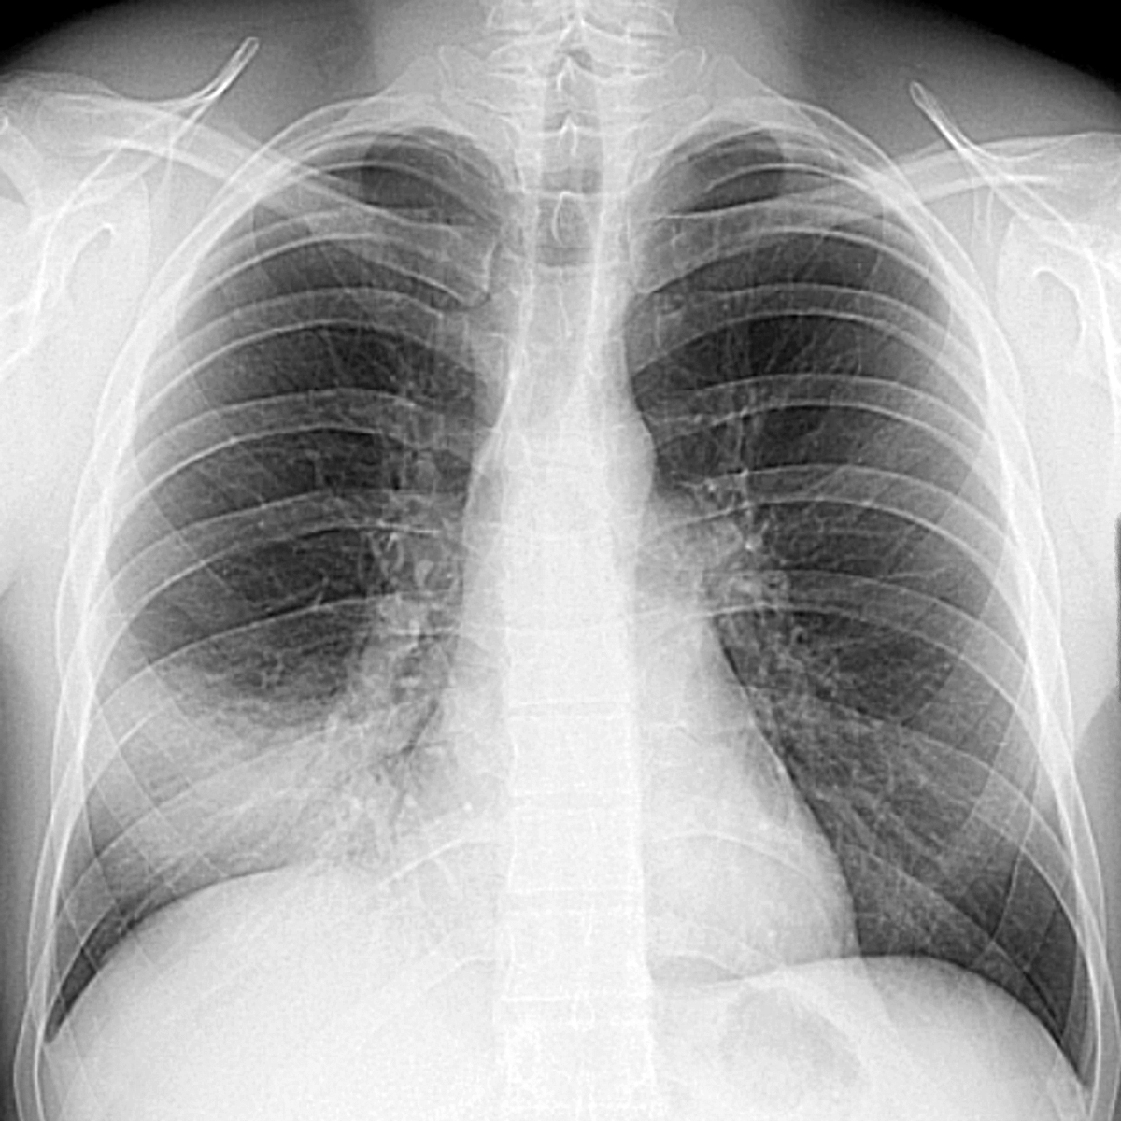

ECG

