Sepsis Cases – Case 1
Summary of Case Scenario:

This 29 year old man has been having worsening abdominal pain for the past 3 days. He has been having more frequent loose bowel movements for the past week, and in the past 2 days has noted some blood in his stool. He has lost his appetite. He has a history of Crohn’s disease, but has not had any abdominal surgeries; over the past 6 months, he has had more frequent flares of diarrhea, but this is much more severe pain than he is used to. In the past day he has had a fever, chills, and worsened pain, with generalized weakness, and lethargy. He reports feeling lightheaded, and had one syncopal episode at home when he tried to get up today, so his girlfriend brought him to the ED. His current medications at home include Imuran, and Tylenol#2 for pain. He has been on prednisone frequently in the past six months, but is not on it at present. He is otherwise healthy, with no other significant medical problems. He lives at home with his girlfriend. He’s had no recent travel, and has no sick contacts.

Equipment Setup & Moulage:

- Human Patient (jr resident?), in hospital gown, on stretcher, connected to monitors with simulated vital signs
- Standard Resuscitation Equipment, central line kit available
- Central line neck set up on small table, covered but available as required.

Participant Roles:

- Patient
- Physician team leader
- 2nd Physician
- Nurses x 2 (will need earpieces)

Mannequin Programming:

Parameter | Initial Setting
HR | 140, sinus
BP | 75/40
RR | 18
Saturation | 93% room air
Temp | 39.2
Eye Opening | n/a

Case Progression:

The patient on initial assessment is pale and diaphoretic, and is in obvious pain and distress. He is hypotensive and tachycardic, but awake and alert/interactive and able to answer questions (but isn’t too keen to talk due to pain). On physical examination, he has a rigid abdomen with diffuse tenderness.

He remains hypotensive despite vigorous fluid resuscitation, and will require central venous catheterization and initiation of vasopressors to support his BP, which will remain low, which should prompt administration of stress-dose steroids.

Urgent surgical consultation should be sought as soon as the subdiaphragmatic air on xray is identified.

Case Stem (Provided to Participants)

This 29 year old male has been brought to the ED with a chief complaint of abdominal pain. The nurses ask you to assess him immediately due to abnormal vital signs.

Information for Standardized patient

You are a 29 year old male patient whose girlfriend brought you to the ER because you’ve been having severe abdominal pain for the past day. The history you should share when asked the appropriate questions, is that your pain started yesterday, has been gradually worsening to the point that you are now extremely uncomfortable and feeling very unwell, with nausea, fever and chills, and loss of appetite. You have been feeling lightheaded and lethargic, and actually had a brief syncopal episode when you got up to go to the bathroom a couple of hours ago.

If asked about medical problems, you should disclose that you were diagnosed with Crohn’s disease as a teenager. You’ve never had any abdominal surgeries. You’ve had more frequent stools/diarrhea over the past 6 months, particularly in the last week, with some intermittent abdominal pain; but never anything like what you have now. You have noticed some blood in your stool for the past 2 days.

You are followed by Dr. Doe in the GI clinic. Your current medications are Pentasa and Tylenol#3, which you take occasionally for pain. If asked, you can disclose that you’ve been treated with prednisone four or five times in the last year for flares of your Crohn’s, but your most recent course finished about two weeks ago.

Laboratory Results

VBG

pH 7.14
pO₂ 40
pCO₂ 28
HCO₃ 10

CBC

WBC 25.2*
Hgb 160
Plt 204

CXR

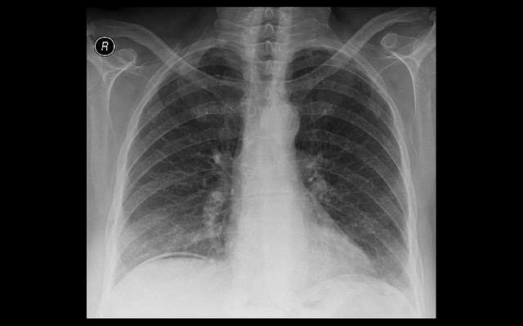

ECG

